

Tribhuvan University
Faculty of Humanities and Social Science

“ThriftZaar Nepal”

A PROJECT REPORT

Submitted to
Department of Computer Application
Bhaktapur Multiple Campus

In partial fulfillment of the requirements for the Bachelors in Computer Application

Submitted by
Kusum Darlami (6-2-20-21-2023)
Sujan Tamang (6-2-20-51-2023)

Under the Supervision of
Bishwa Nath Lal Karn
March, 2026


Tribhuvan University
Faculty of Humanities and Social Science
Bhaktapur Multiple Campus

SUPERVISOR’S RECOMMENDATION

I hereby recommend that this project prepared under my supervision by “Kusum Darlami and Sujan Tamang” entitled “ThriftZaar Nepal” in partial fulfillment of the requirements for the degree of Bachelor of Computer Application is recommended for the final evaluation.

……………………………….
Mr. Bishwa Nath Lal Karn
Supervisor
Bhaktapur Multiple Campus
Dudpati, Bhaktapur


Tribhuvan University
Faculty of Humanities and Social Science
Bhaktapur Multiple Campus

LETTER OF APPROVAL
This is to certify that this project prepared by “Kusum Darlami and Sujan Tamang” entitled “ThriftZaar Nepal” in partial fulfillment of the requirements for the degree of Bachelor’s in Computer Application has been evaluated. In our opinion it is satisfactory in the scope and quality as a project for the required degree.
………………………………………  Mr. Bishwa Nath Lal Karn  Supervisor  Dudpati, Bhaktapur | ………………………………………  Mr. Madan Nath  Coordinator  Dudpati, Bhaktapur
………………………………………  Internal Examiner | ………………………………………  External Examiner

ABSTRACT
This report is submitted in partial fulfillment of the requirements for the Bachelor in Computer Application (BCA) degree at Bhaktapur Multiple Campus. It presents the design and development of “ThriftZaar Nepal,” a web-based platform that facilitates the online buying and selling of second-hand clothing. The system provides users with an easy and convenient way to browse, purchase, and sell pre-owned fashion items through a single digital marketplace. The main objective of this project is to create an effective and user-friendly platform that promotes sustainable fashion while offering individuals an opportunity to generate income by selling unused clothing. The application aims to simplify the process of online transactions, enhance accessibility, and provide an organized system for managing clothing products and users. The system is developed using PHP, Apache, and MySQL for backend development, while HTML5, CSS3, and JavaScript are used for frontend design and implementation. The website ensures efficient management of product listings, user interactions, and online transactions.
Keywords: ThriftZaar Nepal, Second-Hand Clothing, Online Marketplace, Buy and Sell Platform, Web-Based Application.

ACKNOWLEDGEMENT

We would like to express my sincere gratitude to the Faculty of Humanities and Social Sciences, Bhaktapur Multiple Campus, Tribhuvan University, for providing me with the valuable opportunity to undertake this project as a partial fulfillment of the requirements for the Bachelor in Computer Application (BCA) program. This project has been an important platform for enhancing my academic knowledge, practical skills, and professional experience. We would like to extend my profound appreciation to our respected coordinator, Mr. Madan Nath, for his continuous guidance, valuable suggestions, and encouragement throughout the development of this project. We are also deeply indebted to my Project Supervisor, Mr. Bishwa Nath Lal Karn, for his expert supervision, constructive feedback, and constant support, which significantly contributed to the successful completion of this report. Furthermore, We would like to express my heartfelt thanks to all respected faculty members and teachers for their academic guidance and motivation during the course of this project work. Finally, We are deeply grateful to my parents and friends for their unwavering support, encouragement, and cooperation, which enabled me to complete this project within the stipulated timeframe.

TABLE OF CONTENTS
SUPERVISOR’S RECOMMENDATION i
LETTER OF APPROVAL ii
ABSTRACT iii
ACKNOWLEDGEMENT iv
LIST OF FIGURES vii
LIST OF TABLES viii
LIST OF ABBREVIATIONS ix
CHAPTER 1: INTRODUCTION 1
1.1 Introduction 1
1.2 Problem Statement 1
1.3 Objectives 2
1.4 Scope and Limitation 2
1.4.1 Scope 2
1.4.2 Limitations 2
1.5 Report Organization 3
CHAPTER 2: BACKGROUND STUDY AND LITERATURE REVIEW 4
2.1 Background Study 4
2.2 Literature Review 4
2.3 Model Used 5
CHAPTER 3: SYSTEM ANALYSIS AND DESIGN 7
3.1. System Analysis 7
3.1.1 Requirement Analysis 7
3.1.2 Feasibility Analysis 10
3.1.3 Data Modeling (ER-Diagram) 12
3.1.4 Process Modeling (DFD) 13
3.2 System Design 14
3.2.1 Architectural Design 14
3.2.2 Database Schema Design 16
3.2.3 Interface Design 17
3.2.4 Physical DFD 20
CHAPTER 4: IMPLEMENTATION AND TESTING 21
4.1 Implementation 21
4.1.1 Tools Used 21
4.1.2 Implementation Details of Modules 21
4.2 Testing 22
4.2.1 Test Cases for Unit Testing 22
4.2.2 Test Cases for System Testing 25
CHAPTER 5: CONCLUSION AND FUTURE RECOMMENDATIONS 27
5.1. Lesson Learnt / Outcome 27
5.2 Conclusion 27
5.3 Future Recommendations 28
REFERENCES 29
APPENDICES

LIST OF FIGURES
Figure 2.1: Waterfall Model 6
Figure 3.1: Use case diagram of ThriftZaar Nepal...............................................................9
Figure 3.2: ER Diagram of Thriftzaar Nepal 12
Figure 3.3: DFD - 0 (Context Diagram) of Thriftzaar Nepal 13
Figure 3.4: DFD - 1(admin) of Thriftzaar Nepal 13
Figure 3.5: DFD - 1(customer) of Thriftzaar Nepal 14
Figure 3.6: Customer Flowchart of ThriftZaar Nepal 16
Figure 3.7: Database Schema Design 17
Figure 3.8: Wireframe of Login and registration interface 18
Figure 3.9:Wireframe of User dashboard interface 19
Figure 3.10: Wireframe of Admin dashboard interface 19
Figure 3.11: Customer Physical DFD of Thriftzaar Nepal 20

LIST OF TABLES
Table 4.1: Test Case For User Login 23
Table 4.2: Test Case For User Registration 23
Table 4.3: Test Case For Adding and Searching Products 24
Table 4.4: Test Case For Adding Category 24
Table 4.5: Test Case For Adding Products 25
Table 4.6: Test Case For Ordering Product 26
Table C.1: Log Details of Visit to the Supervisor................................................................

LIST OF ABBREVIATIONS
CSS Cascading Style Sheet
DFD Data Flow Diagram
ER Entity Relationship
ES ECMA Script
HTML Hyper Text Markup Language
HTTP Hyper Text Transfer Protocol
IDE Integrated Development Environment
RDBMS Relational Database Management System
SQL Structured Query Language
UI User Interface
CASE Computer-Aided Software Engineering

CHAPTER 1: INTRODUCTION

1.1 Introduction
ThriftZaar Nepal is a web-based platform designed to facilitate the buying and selling of second-hand clothing through an online marketplace. The system allows users to browse various categories of clothing, purchase items online, and sell their own pre-owned clothes easily. Users can register an account, log into the system, view available products and order them efficiently. The platform serves as a convenient and effective medium for conducting online transactions related to second-hand fashion.
In recent years, thrift stores have evolved beyond simple resale outlets and have become important contributors to sustainable living and ethical consumption. By promoting the reuse of clothing items, the platform helps reduce environmental waste while providing users with access to affordable fashion options. ThriftZaar Nepal aims to support individuals who want to buy and sell clothing at reasonable prices through a simple and user-friendly online system.
With the increasing growth of internet usage and e-commerce services, many people prefer accessing services online rather than visiting physical stores or shopping malls. Online platforms help reduce transportation costs, minimize time consumption, avoid traffic, and provide a more convenient shopping experience from home. The availability of modern web technologies has made it possible to develop secure and reliable systems that support online transactions effectively.
The primary focus of this project is to create a centralized platform where users can easily access second-hand clothing suitable for daily needs. Fashion trends change frequently, and individuals often require different styles of clothing. ThriftZaar Nepal provides users with an opportunity to explore a wide range of affordable clothing options with just a few clicks, ensuring convenience, accessibility, and sustainability in the modern digital environment.

1.2 Problem Statement
In recent years, the demand for second-hand clothing has increased significantly due to growing awareness of sustainable fashion and the need for affordable clothing options. Although several physical stores sell second-hand garments, customers often face challenges such as limited accessibility, high pricing of designer items, and restricted product availability. Physical thrift stores incur operational expenses such as rent, staffing, and maintenance costs, which may increase product prices and reduce affordability for many users.
Additionally, most second-hand clothing stores are concentrated in busy urban areas such as New Road, Maitighar, Baneshwor, and similar commercial locations. Customers living in remote or less-developed regions often find it difficult to access these stores due to travel distance, transportation costs, and time constraints. As a result, many potential buyers have limited opportunities to explore affordable and diverse clothing options.
Similarly, individuals who wish to sell their unused clothes encounter several difficulties. Traditional face-to-face selling involves time-consuming negotiations and limited exposure to potential buyers. Sellers often struggle to reach a wider audience and find suitable customers, which reduces the efficiency of the selling process. Furthermore, the absence of a centralized digital platform makes it challenging for both buyers and sellers to connect effectively.
Therefore, there is a need for a structured, accessible, and user-friendly online system that allows individuals to buy and sell second-hand clothing conveniently. The ThriftZaar Nepal project aims to address these issues by providing a centralized web-based platform where users can easily browse, purchase, and sell second-hand clothing from the comfort of their homes, thereby expanding access and improving the overall buying and selling experience.

1.3 Objectives
- To develop an online web-based system for buying second-hand clothing.

1.4 Scope and Limitation

1.4.1 Scope
- Online clothing marketplace.
- User and Admin modules.
- User friendly environment.
- Time efficient.
- Project listing management.

1.4.2 Limitations
Some of the limitations that exist on our site are,
- Limited to web-based platforms.
- Users need to log in to buy clothes.
- No online payment.
- No AI based recommendations.

1.5 Report Organization
This project report is organized into five chapters, each covering distinct phases of the system development process.
Chapter 1: Introduction presents the introduction to the project, including the background, problem statement, objectives, scope and limitations, and overall organization of the report.
Chapter 2: Background study and literature review provides background study and literature review, describing fundamental concepts related to the project and an overview of existing systems along with their advantages and limitations.
Chapter 3: System analysis and design focuses on the system analysis and design phase. It includes requirement analysis, feasibility analysis, data modeling, process modeling, and detailed system design components.
Chapter 4: Implementation and testing describes the implementation and testing of the system. It includes the technologies used, module development, system functionality, and testing procedures conducted to ensure system reliability and performance.
Chapter 5: Conclusion and future recommendations presents the conclusions drawn from the project, lessons learned during development, and recommendations for future improvements and enhancements of the system.

CHAPTER 2: BACKGROUND STUDY AND LITERATURE REVIEW

2.1 Background Study
With the rapid growth of internet usage and the increasing popularity of online shopping, people are now more inclined toward digital platforms for buying and selling products. Online marketplaces provide convenience, accessibility, and time efficiency compared to traditional physical stores [1]. At the same time, awareness of sustainable fashion and the reuse of clothing has grown significantly, leading to a rising demand for second-hand apparel. The reuse of clothing helps reduce textile waste and promotes environmentally friendly consumption practices [2]. However, many existing thrift stores are limited to physical locations, making it difficult for users to access affordable clothing conveniently. Traditional selling methods also lack efficiency and wider market reach for sellers [3].
ThriftZaar Nepal was developed to address these challenges by providing an online platform where individuals can easily buy and sell second-hand clothing from the comfort of their homes. The system aims to combine the advantages of e-commerce technology with sustainable fashion practices, creating a convenient, accessible, and environmentally friendly marketplace for users.

2.2 Literature Review
Several online platforms currently provide services for buying and selling second-hand clothing. However, many existing systems present challenges such as complex navigation, poor user experience, and inefficient product browsing features. These limitations often make it difficult for users to explore available items and complete transactions smoothly. As a result, users may feel discouraged from using such platforms despite the growing demand for affordable and sustainable fashion options. To gain deeper insights into existing systems and understand best practices for implementing the proposed online thrift store system, several established platforms offering similar services were reviewed.
One of the major platforms analyzed was Depop, a peer-to-peer circular fashion marketplace where anyone can buy, sell and discover secondhand fashion [4]. The platform integrates social media features with e-commerce functionality, allowing users to follow sellers, like items, and explore trending fashion styles. Its visually attractive interface and youth-oriented design enhance user engagement, while the product listing process is simple and user-friendly. However, the system is primarily optimized for mobile platforms, limiting desktop accessibility. Additionally, the heavy integration of social networking features may distract users from focused shopping, and administrative control mechanisms are relatively limited compared to structured e-commerce systems.
Another platform reviewed was Thrift Store Nepal, online platform dedicated to making second-hand fashion accessible to everyone in Nepal while promoting a sustainable lifestyle [5]. The platform enables users to browse thrift items and access affordable fashion without visiting physical stores. Its local focus makes it highly relevant to Nepalese consumers, and it allows sellers to upload products free of cost. Despite these advantages, certain limitations were identified, such as the absence of a refund policy for damaged products, limited customer support services, and a user interface that could be improved. The platform also lacks structured automation features and advanced system functionalities commonly found in modern e-commerce applications.
The study also examined eBay, a globally recognized online marketplace that allows users to buy and sell new and second-hand goods [6]. eBay provides auction and fixed-price selling options, secure payment gateways, and strong buyer protection policies. Its well-established reputation and structured administrative system make it reliable for online transactions. However, the platform may appear complex for new users, and service fees can discourage small-scale sellers. Additionally, it is not specifically focused on thrift fashion.
Another platform analyzed was Poshmark, a leading fashion resale marketplace powered by a vibrant, highly-engaged community of buyers and sellers and real-time social experiences [7]. Poshmark combines social interaction with e-commerce by enabling users to share listings, follow closets, and participate in virtual shopping events. The platform offers secure payment processing and shipping integration, which simplifies the transaction process. However, it primarily targets markets outside Nepal and charges commission fees on sales.

2.3 Model Used
For the development of the ThriftZaar, the Waterfall Model was adopted as the software development methodology. In this model each phase of development is completed sequentially.
Phases of Waterfall Model Used in This Project
- Requirement Analysis
In this phase, system requirements were gathered and analyzed. The objectives, user needs, system scope, and feasibility analysis were clearly defined. Functional and non-functional requirements were documented.
- System Design
After analyzing requirements, the system architecture, database design (ER Diagram), Data Flow Diagrams (DFD), Flowcharts were prepared. The user interface layout was also designed in this phase.
- Implementation
During this phase, the system was developed using PHP, MySQL, HTML, CSS, and Bootstrap. Modules such as product management, user authentication, and cart processing were implemented.
- Testing
After implementation, the system was tested using unit testing and system testing methods. Errors and bugs identified during testing were corrected before deployment.
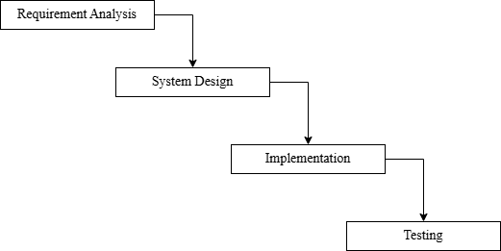
Figure 2.1: Waterfall Model

CHAPTER 3: SYSTEM ANALYSIS AND DESIGN

3.1. System Analysis
System analysis is an important phase carried out before the development of any new system. It involves proper planning of how the system will be designed, developed, tested, implemented, and maintained. [3] Effective system analysis helps in identifying project requirements, defining system objectives, and ensuring smooth workflow throughout the development process. For the successful completion of the project, all team members actively participated in discussions to analyze requirements and to plan the development strategy and overall project workflow.

3.1.1 Requirement Analysis
Requirement analysis is a crucial phase in the system development life cycle, conducted before the implementation of the system. It involves identifying, analyzing, and documenting the needs and expectations of users and stakeholders to ensure that the developed system meets its intended objectives. Proper requirement analysis helps in understanding the functionality of the system, defining system boundaries, and minimizing potential development risks.
For the development of the ThirftZaar system, requirements are mainly categorized into two major groups:
- Functional Requirements
- Non-Functional Requirements
Functional requirements describe the specific operations and services that the system must provide. These requirements represent the user-visible features and interactions within the system. Examples include user registration, login functionality, product listing, order processing, and report generation. Functional requirements are usually defined based on the needs and expectations of stakeholders and end users.
On the other hand, non-functional requirements define how the system performs its functions and the quality attributes it must maintain. These requirements include aspects such as usability, reliability, performance, security, availability, and system implementation constraints. Non-functional requirements ensure that the system operates efficiently, provides good user experience, and maintains data integrity and security.

Both functional and non-functional requirements are essential for designing a reliable and effective system that meets user expectations and supports the overall objectives of the ThirftZaar platform.
- Functional Requirements
- Administrator
  - Manage user accounts (admin-users.php): Admin can create, update, or delete user accounts.
  - Manage products listing (admin-products.php): Admin can view and control all product entries.
  - Manage product categories (admin-categories.php): Admin add/edit/delete product categories in the system.
  - Remove invalid products (admin-delete.php): Admin removes inappropriate or incorrect listings.
  - Login to admin dashboard (login.php): Admin authenticates to access system controls.
- Customer
  - Login and logout from the system (login.php): Customer accesses or exits their account securely.
  - Browse available products (hamro-pasal.php): Customer views available clothing items.
  - Place orders for clothing items (place-order.php): Customer purchases selected products.
  - Search and filter clothing items (hamro-pasal.php): Customer finds items based on preferences.
  - View detailed product information (product.php): Customer sees detailed information about a product.
  - View homepage (index.php): Customer accesses the main entry page of the system.
  - Register a new account. (register-logic.php): Customer creates a new account to use the system.

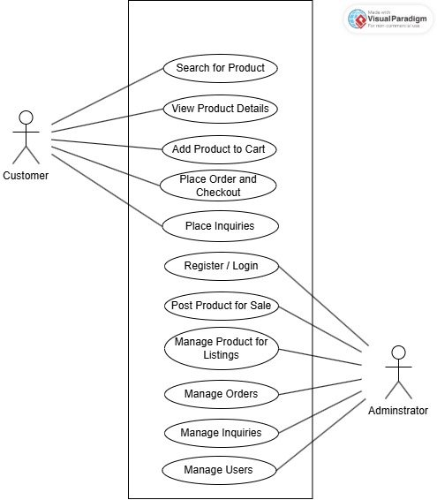

Figure 3.1: Use case diagram of ThriftZaar Nepal
- Non-Functional Requirements
- Usability
The system is intended for a wide range of users, including individuals with basic technical knowledge. Therefore, a simple and intuitive interface is necessary to ensure that users can easily browse products, register, and place orders without confusion. A user-friendly design increases user satisfaction and encourages repeated usage of the platform

- Performance
Fast system response is critical in an e-commerce environment. If pages load slowly or search results take too long, users may leave the platform. Ensuring quick loading time and efficient search functionality improves user experience and system efficiency, especially when multiple users access the system simultaneously.
- Security
Since the system handles sensitive user data such as login credentials and personal information, strong security measures are required. Password encryption, authentication, and protection against common web vulnerabilities help prevent unauthorized access and ensure data privacy and system integrity
- Reliability
The system must function consistently without errors or crashes, especially during transactions such as placing orders. Reliable performance ensures that user data is not lost and that operations are completed successfully, which builds user trust in the platform.
- Availability
As an online marketplace, the system should be accessible at all times so users can browse and purchase products whenever convenient. High availability ensures continuous service and improves user engagement and satisfaction.
- Maintainability
The system is expected to evolve over time with new features and improvements. A modular and well-structured design allows developers to easily update, debug, and expand the system without affecting existing functionalities, ensuring long-term sustainability.

3.1.2 Feasibility Analysis
Feasibility analysis is carried out to determine whether the proposed ThriftZaar Nepal system is practical and achievable within available resources, time, and technology. It helps evaluate whether the system can be successfully developed and implemented to meet the project objectives. The feasibility of the ThriftZaar Nepal project is analyzed under the following aspects:
- Technical Feasibility
Technical feasibility examines whether the necessary technologies, tools, and technical skills required for system development are available. [3] The ThriftZaar Nepal system is developed using standard web technologies such as HTML5, CSS3, JavaScript, PHP, Apache Server, and MySQL database, which are widely used and freely available. These technologies are compatible with most operating systems and do not require high-end hardware.
The development team possesses sufficient programming knowledge and experience to design and implement the system effectively. Development tools such as code editors, local servers, and web browsers are easily accessible. Since the application is web-based and runs on standard hosting environments, no specialized infrastructure is required. Therefore, the project is technically feasible.
- Operational Feasibility
Operational feasibility evaluates whether the system will function effectively in a real-world environment and whether users can easily operate it. The ThriftZaar Nepal platform is designed with a simple, user-friendly interface that allows users to browse clothing items, upload products, and manage listings with ease. The admin panel provides efficient management of products, categories, and users. Since the platform requires only basic computer and internet knowledge, users can operate it without extensive training. Hence, the system is operationally feasible.
- Economic Feasibility
Economic feasibility analyzes the financial viability of the project. The ThriftZaar Nepal system is developed using open-source technologies, which eliminates licensing costs. The project is carried out by students as part of academic coursework, reducing development expenses. The system requires only basic computing resources and low-cost web hosting for deployment. Maintenance and operational costs are minimal due to the simple design and widely supported technologies. Considering the low investment and potential benefits of providing an affordable online clothing marketplace, the project is economically feasible.

- Schedule Feasibility
Schedule feasibility determines whether the project can be completed within the allocated timeframe. The development of ThriftZaar Nepal follows a structured project plan that includes requirement analysis, system design, implementation, testing, and documentation phases. Tasks are distributed among team members to ensure efficient progress. Since the system uses familiar technologies and has a well-defined scope, it can be completed within the academic project schedule. Therefore, the project is schedule feasible.

3.1.3 Data Modeling (ER-Diagram)
The ER diagram represents the conceptual data model of the ThriftZaar Nepal system. It shows the main database entities such as Admin, Users, Clothes, Categories, and Orders, along with their relationships. The diagram illustrates how data is structured, connected, and managed within the system. It helps in organizing the database design, maintaining data integrity, and supporting efficient system functionalities. [3]
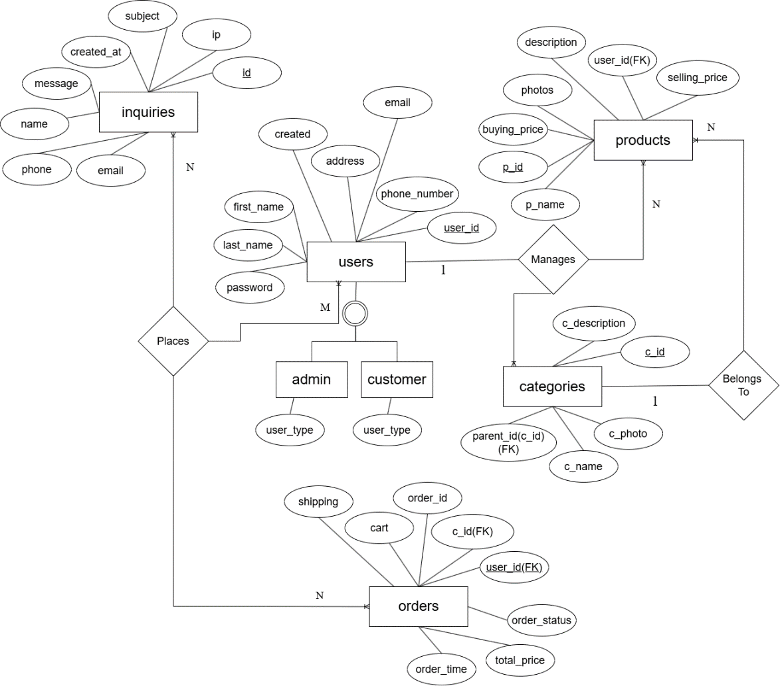
Figure 3.2: ER Diagram of Thriftzaar Nepal

3.1.4 Process Modeling (DFD)
Process modeling is used to represent how data moves through the ThriftZaar Nepal system and how different users interact with the system processes. Data Flow Diagrams (DFDs) illustrate the flow of information between users, system processes, and the database. The DFD helps in understanding system functionality and the interaction between various components. The DFD for the ThriftZaar Nepal system is divided into two levels:
- DFD Level 0 (Context Diagram)
- DFD Level 1 (Detailed System Processes)
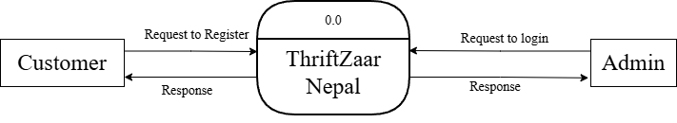
Figure 3.3: DFD - 0 (Context Diagram) of Thriftzaar Nepal
The above picture represents DFD level 0 of our application. The functionalities that can be done are roughly shown in the figure.
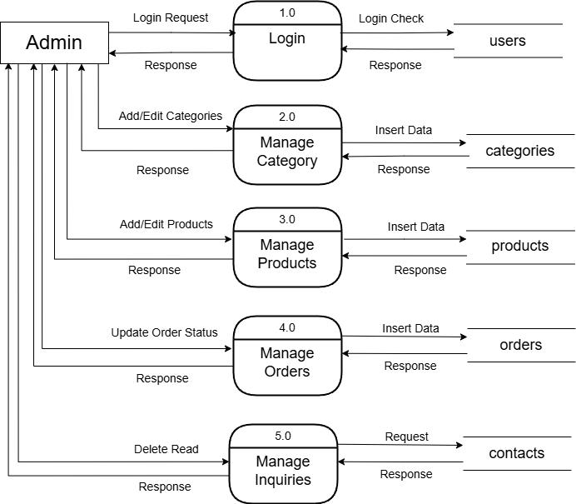
Figure 3.4: DFD - 1(admin) of Thriftzaar Nepal
In the above DFD level 1 we can see all the operations that can be done by the admin.
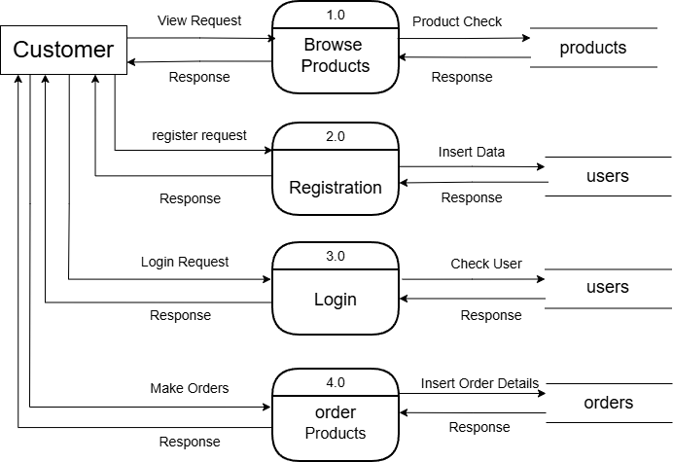
Figure 3.5: DFD - 1(customer) of Thriftzaar Nepal

3.2 System Design

3.2.1 Architectural Design
Architectural design defines the overall structure of the system and shows how different components interact with each other. It provides a high-level view of the system, including modules, data flow, and communication between users, admin, and the database. The main purpose of architectural design is to ensure the system is scalable, maintainable, secure, and easy to manage.
For this Second-Hand Clothing Web Application (ThriftZaar Nepal), three-tier architecture is used:
- Presentation Layer (User Interface)
This layer is responsible for interaction between the system and users (Admin, User, Guest). It includes:
  - Home page
  - Product listing page
  - Login and signup page
  - Admin dashboard
  - Technologies: HTML, CSS, JavaScript, Bootstrap

- Application Layer (Business Logic)
This layer handles the main processing and system functionality.
It performs:
  - User authentication and authorization
  - Product management
  - Order and listing handling
  - Validation of user input
  - Communication between interface and database
  - Technology: PHP
- Data Layer (Database)
This layer stores and manages system data. It includes:
  - User Table
  - Product Table
  - Category Table
  - Technology: MySQL Database
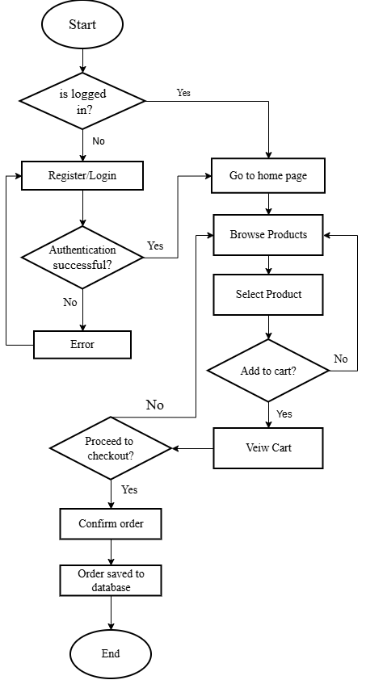
Figure 3.6: Customer Flowchart of ThriftZaar Nepal

3.2.2 Database Schema Design
A database schema is the structure that represents the logical view of the entire database. It defines how the data is organized and how the relations among them are associated. It formulates all the constraints that are to be applied to the data.
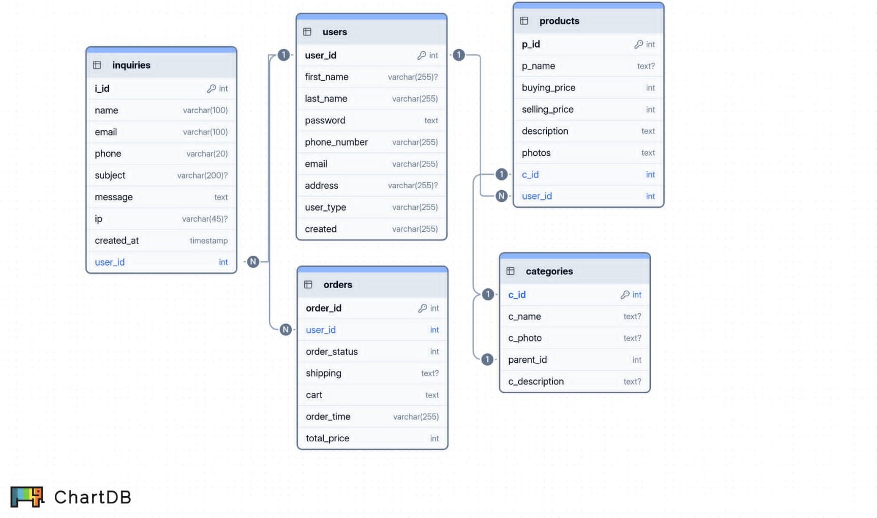
Figure 3.7: Database Schema Design
Here in the above figures show us the schema diagram of our application. It shows the connection between various tables.

3.2.3 Interface Design
Before implementing the actual design of the project, a few user interface designs are constructed to visualize the user interaction with the system as they browse for clothes, search, register, login and purchase. The main objective of the interface design is to provide a simple, user-friendly, and efficient environment where users and administrators can easily interact with the system. The interfaces are designed to be responsive, accessible, and easy to navigate for different types of users including Guests, Registered Users, and Administrators. The interface structure is divided into different modules based on user roles and system functionalities.
A. Login and Registration Interface
This interface allows users and administrators to authenticate themselves into the system.
Login Interface Features:
- Email input
- Password input
- Login button
Registration Interface Features:
- Name input
- Email input
- Password creation
- Contact information
- Submit button
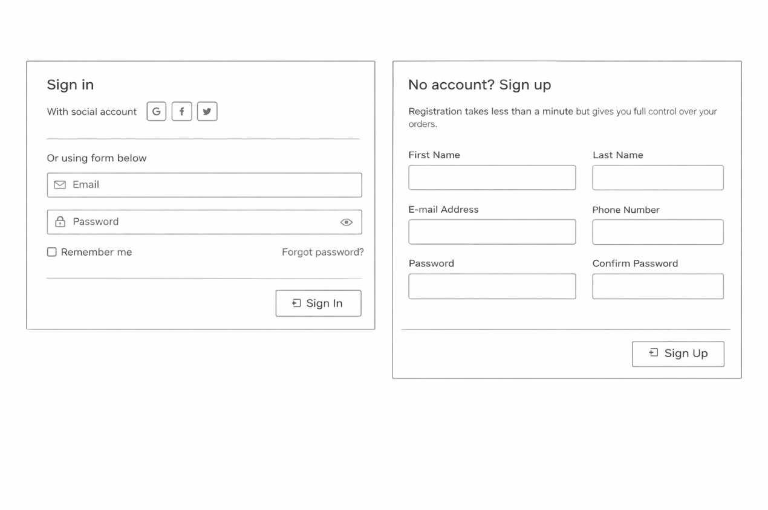
Figure 3.8: Wireframe of Login and registration interface
B. User Dashboard Interface
The user dashboard allows registered users to manage their account and purchases.
Features:
- Profile management
- Order history
- Sign out option
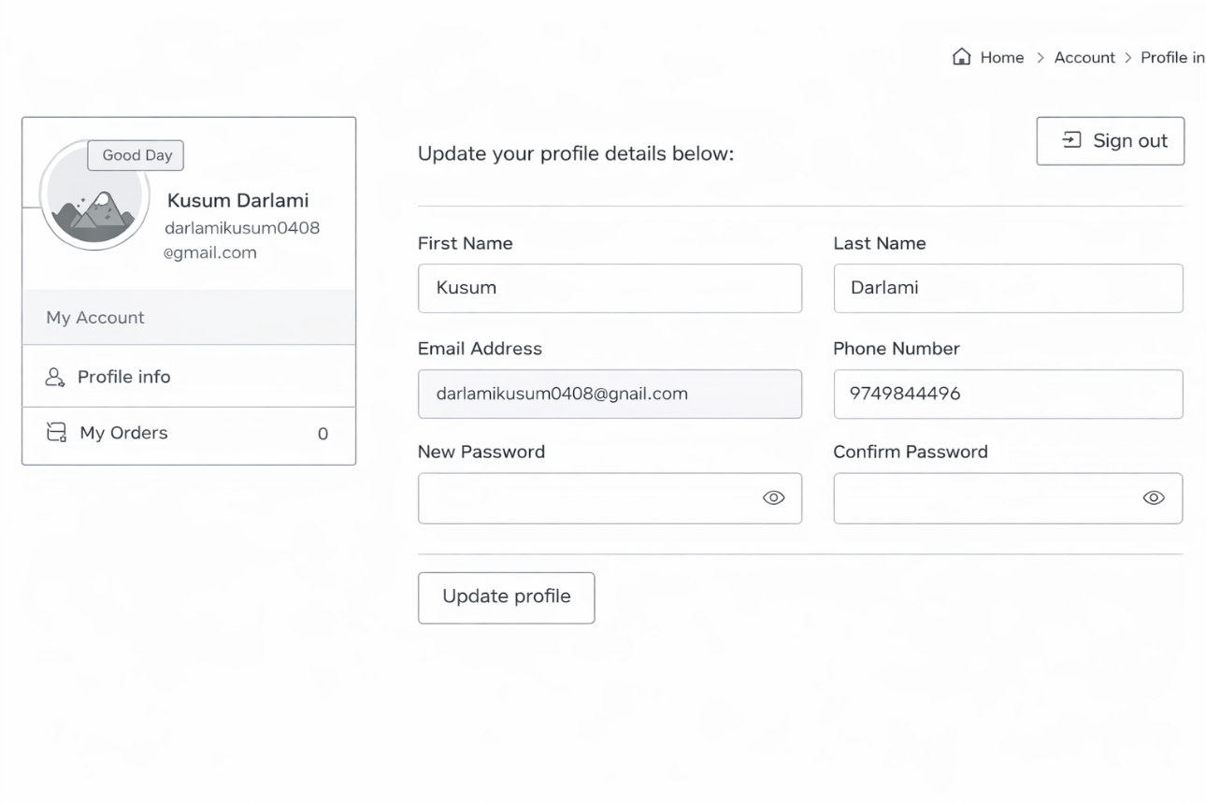
Figure 3.9:Wireframe of User dashboard interface
C. Administrator Dashboard Interface
The administrator dashboard provides system control and management functionality.
Features:
- Manage users
- Add/Edit/Delete products
- Manage categories
- Monitor orders
- System management panel
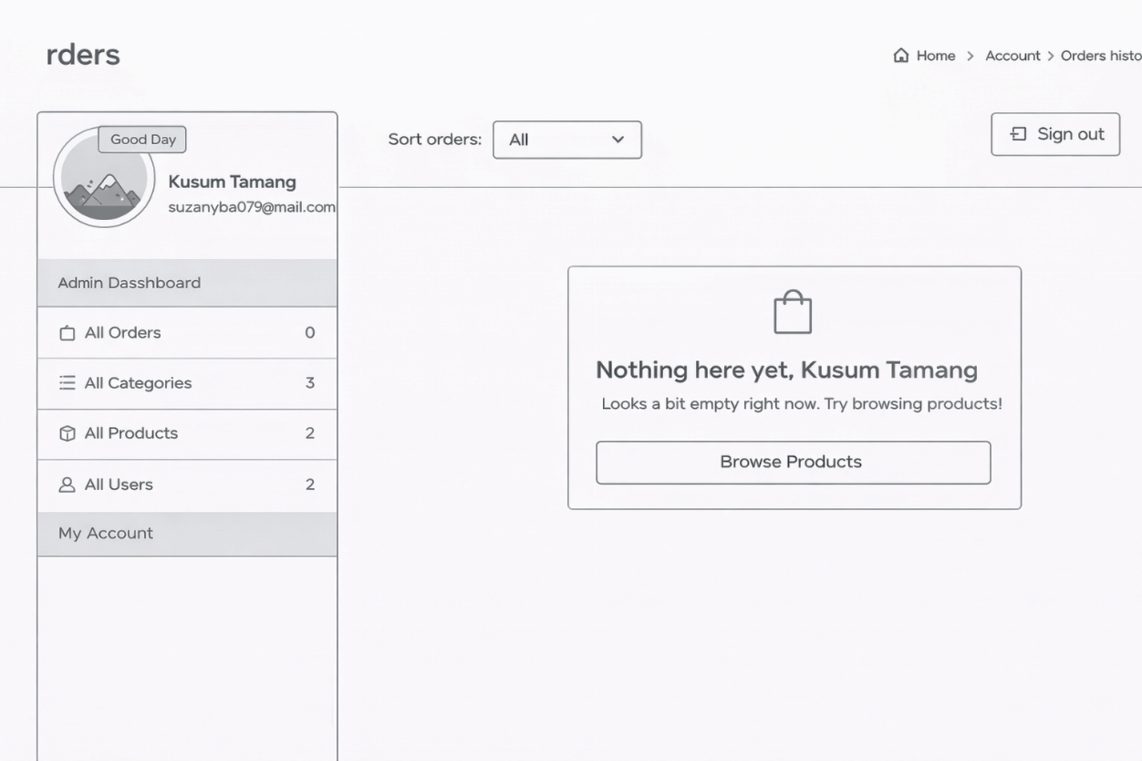
Figure 3.10: Wireframe of Admin dashboard interface

3.2.4 Physical DFD
The Physical DFD of ThriftZaar Nepal illustrates the actual implementation of system processes, user interactions, and database operations. It shows how users and administrators interact with the system through physical components such as web forms, PHP scripts, and MySQL databases.

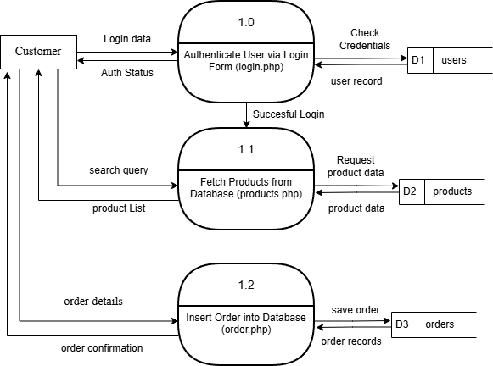
Figure 3.11: Customer Physical DFD of Thriftzaar Nepal
Users and guests can register, log in, browse products, search for clothing items, and place orders through the web interface. All authentication and data processing are handled by server-side PHP scripts, and data is stored and retrieved from MySQL database tables such as User, Product, and Order.

CHAPTER 4: IMPLEMENTATION AND TESTING

4.1 Implementation
After completing the design phase of the system, the next step is implementation so that the system can be deployed according to user requirements and satisfaction. The implementation phase involves various technical processes, resources, and detailed procedures. Since it is not possible to include every technical detail within the scope of this report, only the major aspects and key components of the system implementation are discussed in the following sections.

4.1.1 Tools Used
The development of ThriftZaar Nepal required a combination of programming languages, database platforms, and software tools. These tools were carefully chosen to ensure efficiency, compatibility, and maintainability:
- CASE Tools: CASE tools like draw.io, were used for system modeling, diagramming, and documentation. These tools helped in maintaining clear workflows and understanding relationships between different modules.
- Programming Languages:
HTML5, CSS3, JavaScript, Bootstrap are used to create a responsive and interactive user interface that is compatible with multiple devices. PHP is used for implementing the business logic and server-side operations such as authentication, order processing, and product management.
- Database Platform: MySQL is used to store and manage all system data, including user accounts, product listings, orders, and categories.
- Development Environment Local servers such as XAMPP and LAMP, along with code editors like VS Code, were used to write, test, and debug code efficiently.
These tools provided a robust foundation for building a system that is scalable, secure, and easy to maintain.

4.1.2 Implementation Details of Modules
The ThriftZaar Nepal system is divided into several functional modules, each designed to handle a specific set of tasks. The implementation of each module was carried out using PHP scripts that interact with the MySQL database and the front-end interface. The major modules are described below:
- Admin Module: The Admin module is responsible for managing the entire platform. Administrators can manage users, products, categories, and orders. The key procedures include:
  - admin-product-add.php - Adds new products to the system by collecting product details from the admin interface, validating inputs, and storing them in the database.
  - admin-product-delete.php - Deletes invalid or outdated products from the database.
  - admin-product-edit.php - Updates existing product information, ensuring data consistency.
  - admin-categories-add.php – Adds new categories to the system.
- Customer Module: Registered users can browse, search, and purchase products. Important scripts include:
  - cart-process-add.php - Adds selected products to the user’s cart, verifying quantity and availability before updating the cart table.
  - login.php - Authenticates users before granting access to their dashboard.
  - complete-order.php - Processes orders and updates the orders and inventory tables.
  - hamro-pasal.php - Displays available clothing items on the product page and allows searching and filtering of products.
  - product.php - Provides detailed information about selected products.

4.2 Testing
Testing is an integral part of system development. It ensures that the system functions correctly, meets the specified requirements, and provides a seamless experience to users. The testing of ThriftZaar Nepal was carried out in multiple stages, including unit testing and system testing.

4.2.1 Test Cases for Unit Testing
Unit testing focuses on verifying that each individual module works as intended. By testing functions and procedures independently, errors can be identified and corrected at an early stage. We both acted as a tester and tested most of the major and minor functionalities of web app and recorded the outputs on the tables below:

Table 4.1: Test Case For User Login
Test Id | Description | Test Data | Expected Output | Actual Output | Result
TC_01 | User enters a wrong password | Email:suzanyba079@gmail.com  Password: pass123 | Display :  “Login Failed! You entered wrong email or password.’ | As Expected, | Pass
TC_02 | User enters correct password | Email:suzanyba079@gmail.com  Password: admin | Logged into user profile page | As Expected, | Pass

Table 4.2: Test Case For User Registration
Test Id | Description | Test Data | Expected Output | Actual Output | Result
TC_03 | User tries to register into the system with registered email. | First Name : Sujan  Last Name: Tamang  Email:suzanyba079@gmail.com  Phone : 9762447050  Password: pass1  Confirm Password:pass1 | Display :  “You already have an account with this email address!’ | As Expected, | Pass
TC_04 | User register with new email. | First Name : Kusum  Last Name: Darlami  Email:darlamikusum@gmail.com  Phone : 9749844496  Password: pass1  Confirm Password:pass1 | Logged into user profile page | As Expected, | Pass
Table 4.3: Test Case For Adding and Searching Products
Test Id | Description | Test Data | Expected Output | Actual Output | Result
TC_05 | Admin tries to add a new product | Product Name : Blazer  Product Category: Women  Photos: blazer.jpg  Buying Price: 1000  Selling Price: 1500  Description: Good Quality Blazer, Size: 37, length: 27 | Display :  “Product Added Success Fully’ and go to admin product page | As Expected, | Pass
TC_06 | User Searching for a product | Denim Jacket product is in the shop, and user search key is denim | Matching products displayed | As Expected, | Pass

Table 4.4: Test Case For Adding Category
Test Id | Description | Test Data | Expected Output | Actual Output | Result
TC_07 | Adding the new category by admin | Category Name: Sweatshirt  Photo: sweatshirt.jpg  Parent Category: Men  Description: Men good quality sweat shirts | Displays: “Category added successfully” and redirect to all categories page | As Expected, | Pass

4.2.2 Test Cases for System Testing
System testing evaluates the integrated system as a whole. It ensures that all modules interact correctly and that the system meets both functional and non-functional requirements. Example test scenarios include:
Table 4.5: Test Case For Adding Products
Test Case Id : TC_08 |  |  |  | Test Designed by: Sujan Tamang
Test Title: Verifying the process of adding products |  |  |  | Test Executed by: Kusum Darlami
Description: Test the add products of ThriftZaar Nepal.
Pre-conditions: Admin is logged in to the system.
Steps | Test Steps | Test Data | Expected Output |  | Actual Output | Status
1 | Navigate to add product menu | click | Redirect to add product page |  | As Expected | Pass
2 | Enter all required details and click save product button | All required products data | Show success message and redirect to admin products page |  | As Expected | Pass
Post-condition: Product is successfully added

Table 4.6: Test Case For Ordering Product
Test Case Id : TC_09 |  |  |  | Test Designed by: Sujan Tamang
Test Title: Verifying the process of ordering products |  |  |  | Test Executed by: Kusum Darlami
Description: Test the order products of ThriftZaar Nepal.
Pre-conditions: Customer is logged in to the website and has items in cart.
Steps | Test Steps | Test Data | Expected Output |  | Actual Output | Status
1 | Navigate to proceed to checkout button in cart page | click | Redirect to checkout page page |  | As Expected | Pass
2 | Fill the shipping details in checkout page and click on proceed to review button | All required information in the form. | Redirect to review page |  | As Expected | Pass
3 | Check the shipping and product details and click on place order button | click | Show success message |  | As Expected | Pass
Post-condition: Product is successfully ordered.

CHAPTER 5: CONCLUSION AND FUTURE RECOMMENDATIONS

5.1. Lesson Learnt / Outcome
The development of the ThriftZaar Nepal system provided valuable practical experience in applying software engineering concepts to a real-world web application project. Throughout the project lifecycle, starting from requirement analysis to system implementation and testing, the development we gained a deeper understanding of structured system development processes.
One of the major outcomes of this project was the improvement of technical skills in web development technologies such as HTML, CSS, JavaScript, PHP, and MySQL. We learned how to design user-friendly interfaces, implement secure authentication systems, and manage relational databases effectively. Additionally, knowledge of system modeling techniques such as ER diagrams, DFDs, and architectural design was strengthened during the planning and design phases.
The project also enhanced teamwork and communication skills. Collaborating on tasks such as requirement gathering, system design, coding, debugging, and testing helped the team understand the importance of coordination and proper task distribution. Problem-solving abilities were improved by identifying system errors, debugging code, and optimizing performance. Overall, this project provided hands-on experience in building a complete web-based application and strengthened both technical and project management skills.

5.2 Conclusion
The ThriftZaar Nepal system was successfully designed and developed as a second-hand clothing web application that connects buyers and sellers through an easy-to-use online platform. The system meets the functional and non-functional requirements defined during the analysis phase and provides a secure, responsive, and user-friendly environment for users, guests, and administrators.
The application allows users to browse clothing items, search for products, manage accounts, and place orders efficiently. The administrator has full control over product listings, categories, and user management through a dedicated dashboard. The implementation of a three-tier architecture ensures that the system is scalable, maintainable, and organized.
Testing results confirmed that the system performs reliably and meets performance, usability, and security requirements. The use of open-source technologies helped in minimizing development costs while ensuring compatibility across different platforms and devices.
In conclusion, ThriftZaar Nepal demonstrates the successful application of system analysis, design principles, and modern web technologies to develop a functional and practical web-based marketplace solution.

5.3 Future Recommendations
Although the current version of ThriftZaar Nepal fulfills its primary objectives, several improvements and additional features can be implemented in future versions to enhance system functionality and user experience. Some recommendations include:
- Online Payment Integration: Implement secure digital payment systems such as eSewa or Khalti to allow direct online transactions.
- Mobile Application Development: Develop a mobile application to provide easier access for users on smartphones.
- Advanced Search and Recommendation System: Introduce AI-based product recommendations and improved filtering options.
- User Review and Rating System: Allow users to review and rate products and sellers to improve trust and transparency.
- Real-Time Notifications: Implement email or SMS notifications for order updates and account activities.
- Performance Optimization: Improve system performance through caching techniques and optimized database queries.
- Multi-Vendor Support: Allow multiple sellers to manage their own products independently within the platform.
These future improvements can make ThriftZaar Nepal more scalable, secure, and competitive in the online clothing marketplace environment.

REFERENCES

[1] | K. C. Laudon and C. G. Traver, "E-commerce: Business, Technology, Society," Pearson, 2020.
[2] | UNEP, "Sustainable Fashion Communication Playbook," [Online]. Available: https://www.unep.org. [Accessed 2 April 2026].
[3] | S. R. Saud and M. Giri, "Software Engineering," KEC Publication and Distribution pvt.ltd, 2077.
[4] | depop, "about," [Online]. Available: https://www.depop.com.
[5] | T. Nepal, "About Us," [Online]. Available: https://www.thriftstorenepal.com.
[6] | ebay. [Online]. Available: https://www.ebayinc.com/.
[7] | Poshmark, "About," [Online]. Available: https://poshmark.com/about.

APPENDICES
Appendix A: Screen Shots
This section includes important screenshots of the system interfaces that visually represent the functionality and usability of the application. The screenshots are captured during system execution to show real-time operation of different modules.

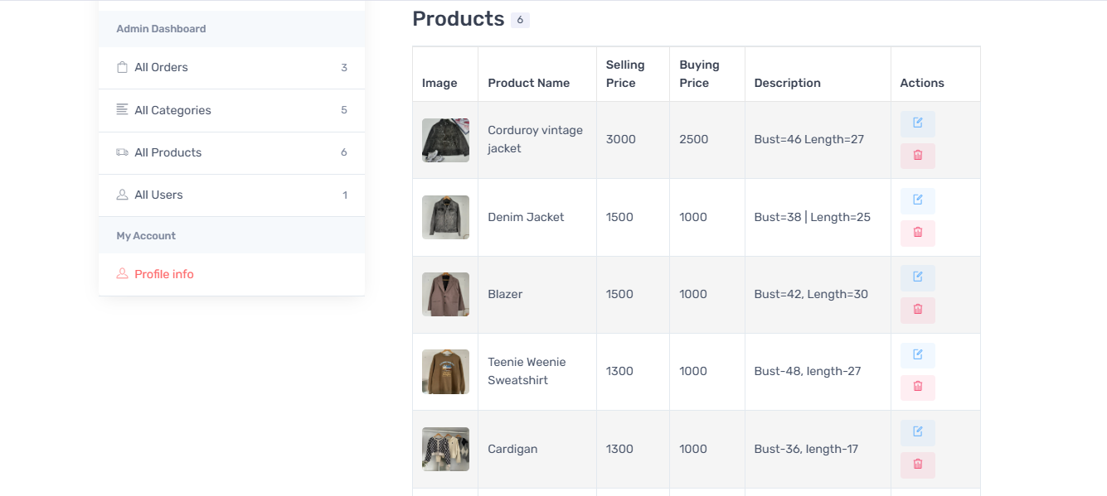
Figure A.1: Product Listing Page

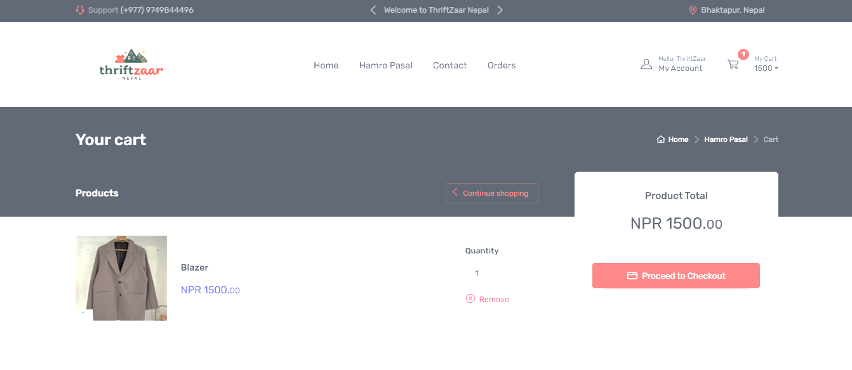
Figure A.2: Cart Page

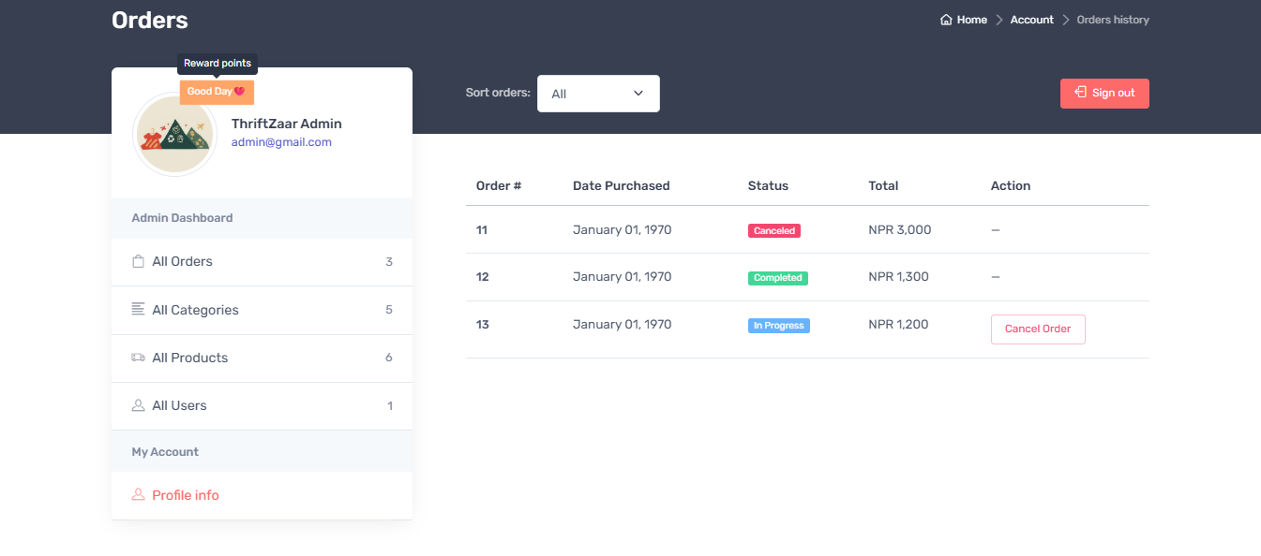
Figure A.3: Admin Order Listing Page

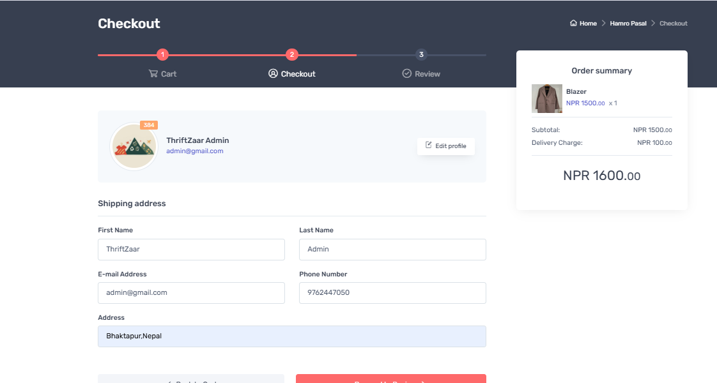
Figure A.4: Checkout Page
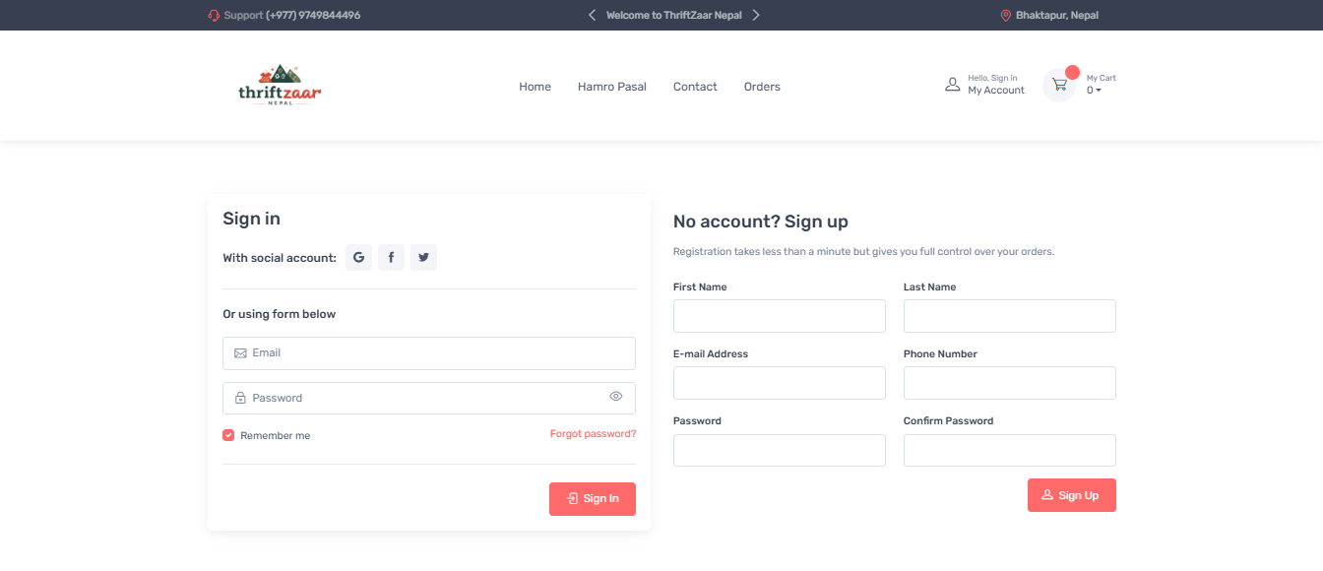
Figure A.5: User Registration and Login Page

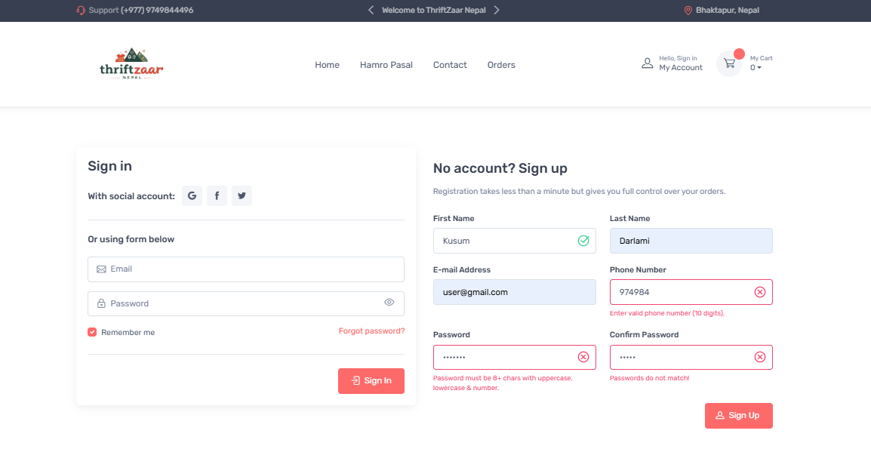
Figure A.6: Client-Side Validation
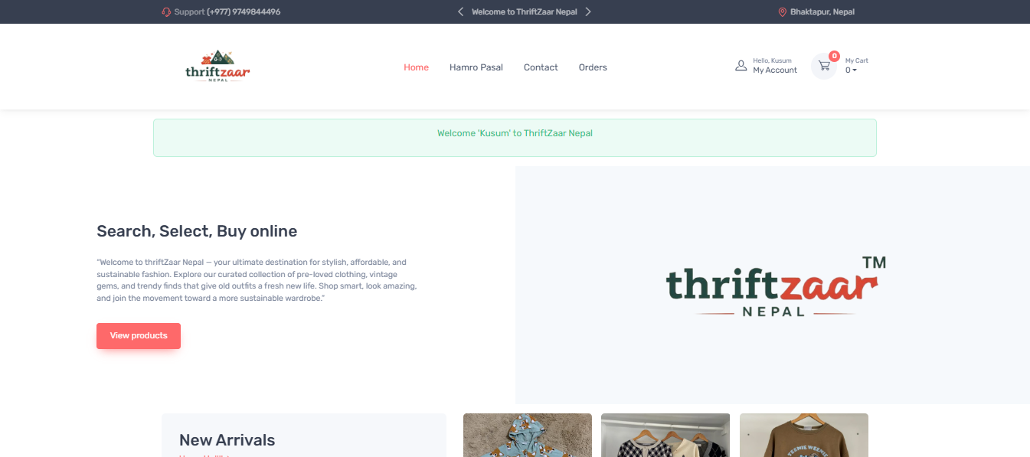
Figure A.7: Successful Registration

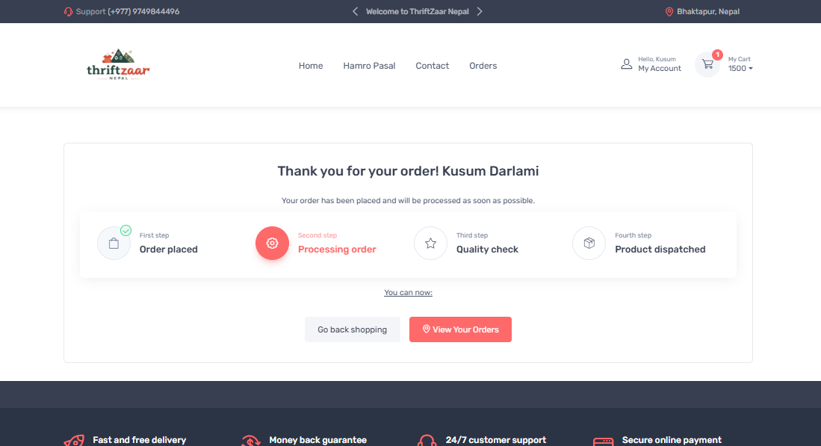
Figure A.8: Order Completion Page

Appendix B: Source Codes
This section contains selected and important source code files used in the development of the ThriftZaar Nepal system.

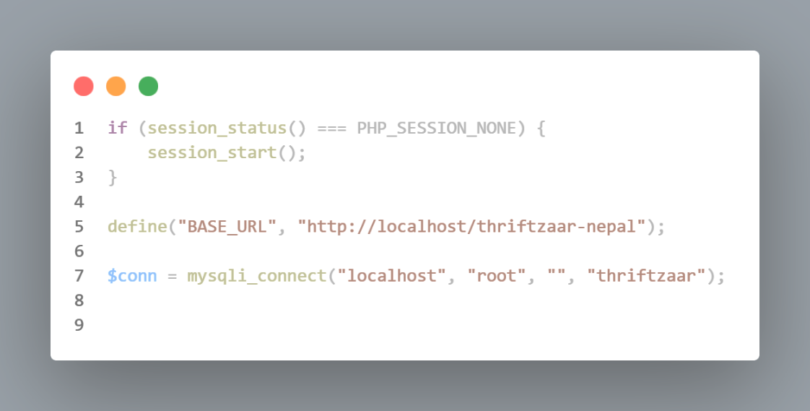
Figure B.1: Database Configuration
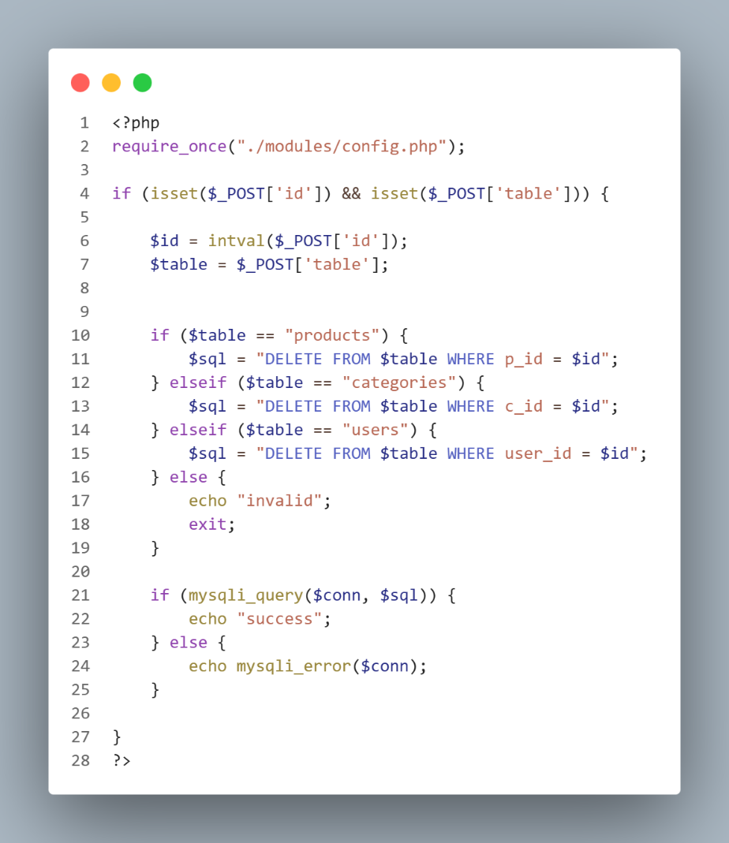
Figure B.2: admin-remove.php

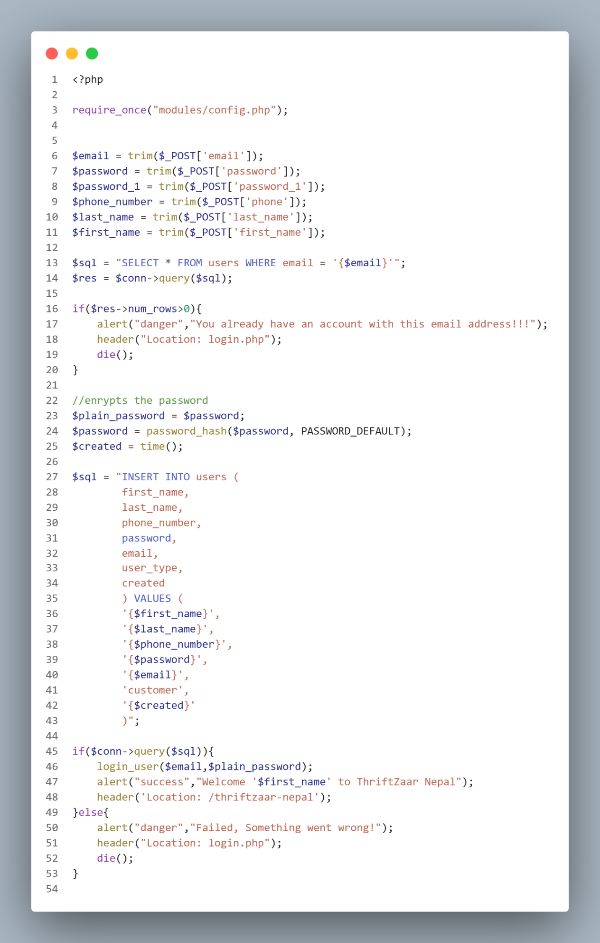
Figure B.3: register-logic.php
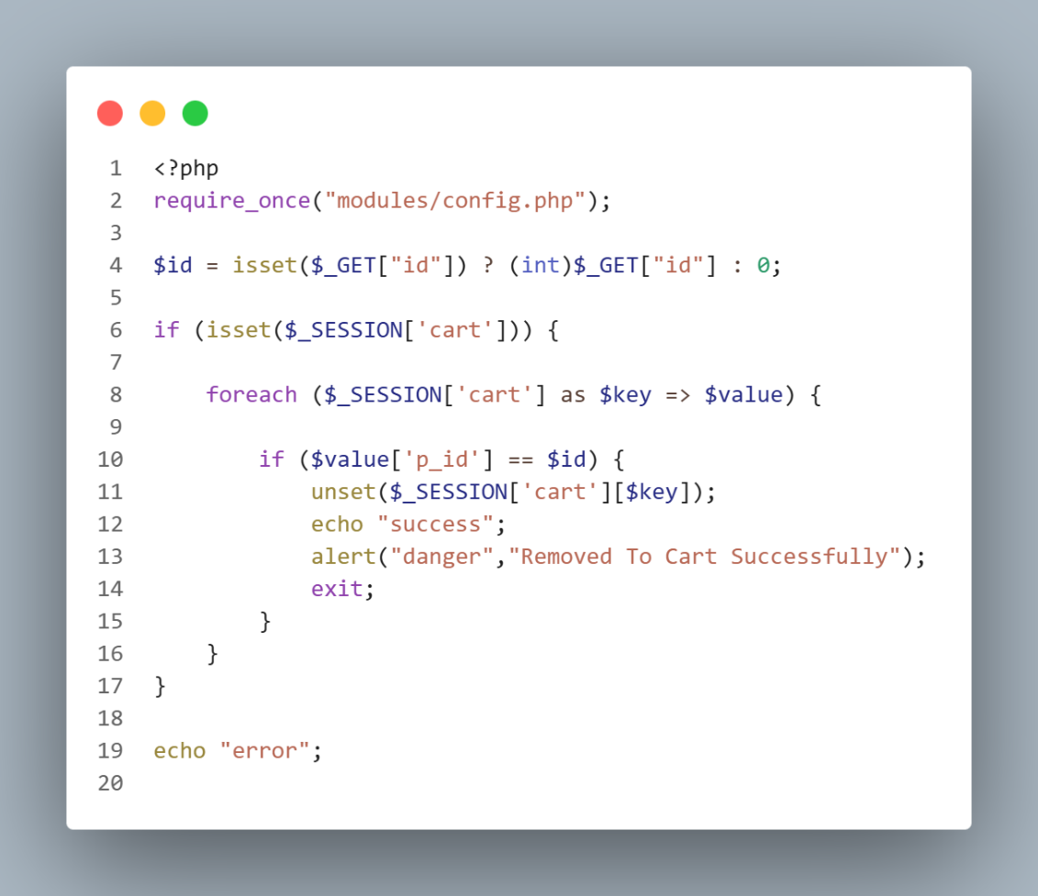
Figure B.4: cart-process-remove.php

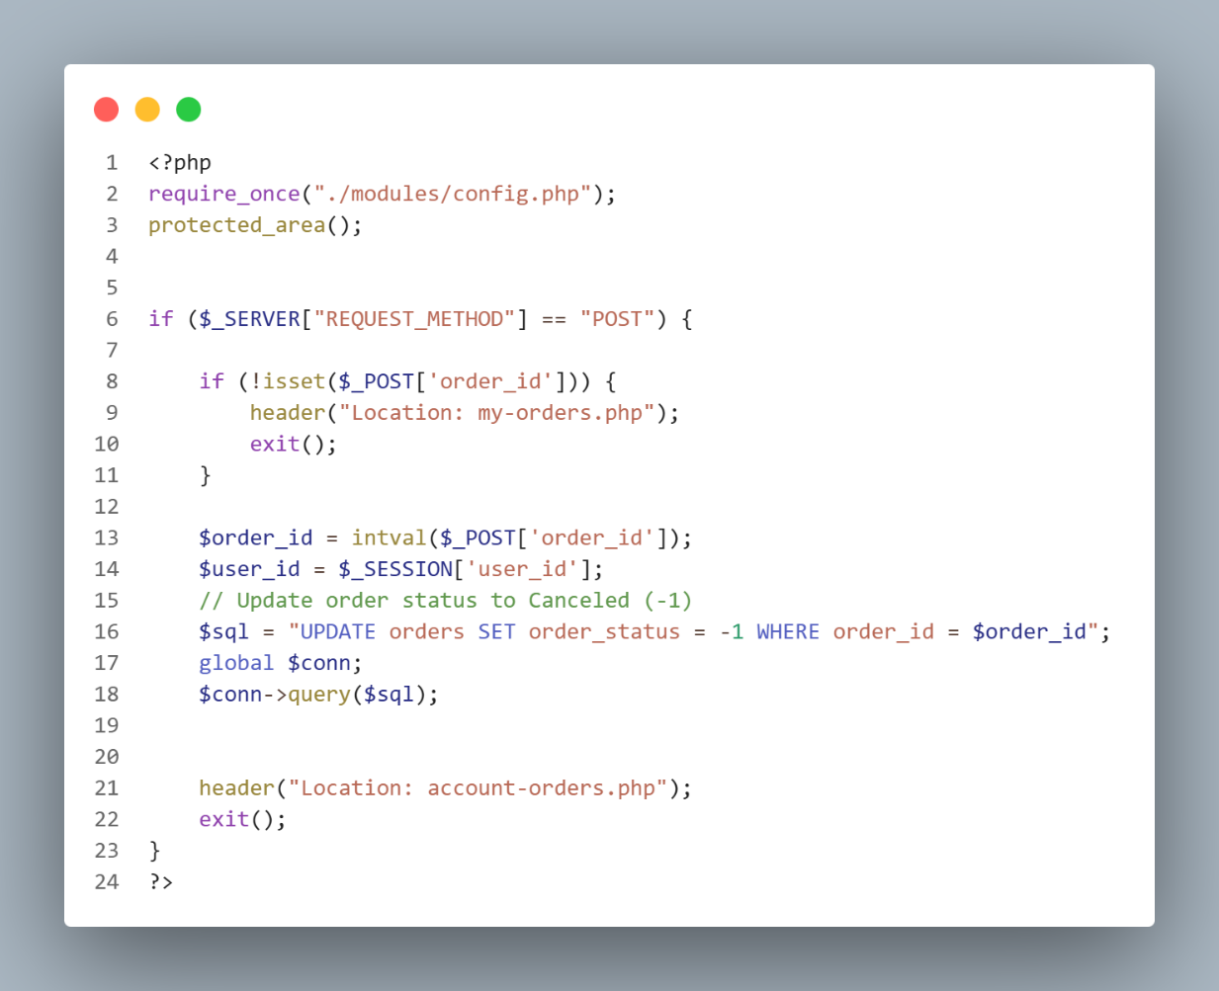
Figure B.5: cancel-order.php

Appendix C: Supervisor Visit Log Sheets
Table C.1: Log Details of Visit to the Supervisor
Date | Meeting Discussion | Signature
23 Feb, 2026 | Reviewed DFD and ER diagrams.
25 Feb, 2026 | Reviewed module descriptions and system flowchart
30 Mar, 2026 | Submitted the mid-defense report for review
1 April, 2026 | Suggested to add the change flowchart, physical dfd, ER diagram, Usecase diagram
3 April, 2026 | Submitted final defense report for review and supervision

……………………………….
Mr. Bishwa Nath Lal Karn
Supervisor
Bhaktapur Multiple Campus
Dudpati, Bhaktapur

